Software Design
Document

Virtual City Hall

Albu Anda Date: 02.12.2012
CiuluRazvan
Table of Contents
1 Introduction 1
1.1 System Overview 1
1.2 Definitions, Acronyms, and Abbreviations 1

2 Design Considerations 3
2.1 Assumptions 3
2.2 Constraints 3
2.3 System Environment 3
2.4 Design Methodology 3
3 Architectural (High-level) Design 4
3.1 Overview 6
3.2 Rationale 6
3.3 Conceptual (or Logical) View 6
4 Low Level Design 7
4.1 General Module 7
5 User Interface Design 8
5.1 Application Control 8

Introduction

System Overview

Virtual City Hall is an application that will assist the mayor of a town in managing organizational details of the institution, in communication with the citizens and the management of the document flow.
The software product will be divided into two types: server application (the main application - designed only for mayor) and a small client application (the secondary application - for citizens use).
The secondary application has only one module that will implement socket communication with the main server (application).
The main application is divided into three modules.
Module 1: This module will manage the city hall structure and the corresponding graphical representation of it. It will also manage the graphical interface of the application.
Module 2: Will handle the communication between the mayor and the citizens. Communication will be done via the Internet.
Module 3: Consists in organizing the documents. It will allow printing, scanning and ordering by different categories.
The departments will be chosen from a list of predefined names. New departments can be added and saved. The graphical representation of the city hall's structure will allow detailed visualization of the departments, employees and relations between entities. Additional information can be added to reflect the current state of the city hall structure.
The main application will automatically schedule audiences based on the citizens requests and contact them at the specified date and time.
The retrieval of the documents will be made depending on document name, author or category and will be stored on server by categories.
The current software product with the corresponding database are independent (do not depend on other software products).

Definitions, Acronyms, and Abbreviations
City Hall Structure represents organizational details, the subordination and links between individuals and departments within an institution.
Online audience is an appointment via the Internet given to an applicant by a person holding a position of responsibility.
Document flow management is a system that allows circulation (for information, approval or amendment), storage and retrieval of documents in electronic format, with facilities to connect to other computer systems or electronic devices.

Acronym or abbreviation | Definition
VCH | Virtual City Hall
CHS | City Hall Structure
OA | Online audience
DFM | Document flow management

Design Considerations

Assumptions
It is assumed that the computer has an internet connection and Java (JRE) installed in order to run both applications. Also it is required a MySQL server for database communication.

Constraints
- Platform: works on any operating system with JRE installed.
- Operating system: Windows XP and above, Linux
- Hardware: - 256 MB RAM
- 1GB free on HDD
- Processor: 1GHz
- Network: internet connection required;

System Environment
The system runs on a Java Virtual Machine and need a MySQL server in order to connect and communicate with the database.
There are no specific requirements for the system, other than the assumptions made in section 2.1 and the constraints made in section 2.2.

Design Methodology
There will be used object-oriented techniques with UML.

Architectural (High-level) Design
a) Server (main) application:
Interface Layer
User Interface
CHS manager

Communication Layer
Socket communication

Storage Layer

Document Manager

b) Secondary application (client application):

Interface Layer
User Interface

Socket communication
Communication Layer

Overview
Main application will be organized into three layers: interface layer, communication layer and storage layer. The interface layer will be the graphical user interface that will allow users to interact with the system and manage CHS. It will be implemented using Java Swing Package. The communication layer will handle messages from and to clients (citizens). It will use sockets (TCP/IP protocol) and will be implemented using java.net Package. Storage layer will contain rules of storing and retrieving documents.

Rationale
This architecture was chosen to separate the user interface, the storage and the communication with clients. Changes made into one layer will not produce major changes into other layers. This layers architecture makes the system more maintainable and reusable.

Conceptual (or Logical) View

Subsystem Component Diagram

User Interface Subsystem
<<component>>
Communication Subsystem
<<component>>

Storage Subsystem
<<component>>
CHS Manager Subsystem
<<component>>

Low Level Design

General module

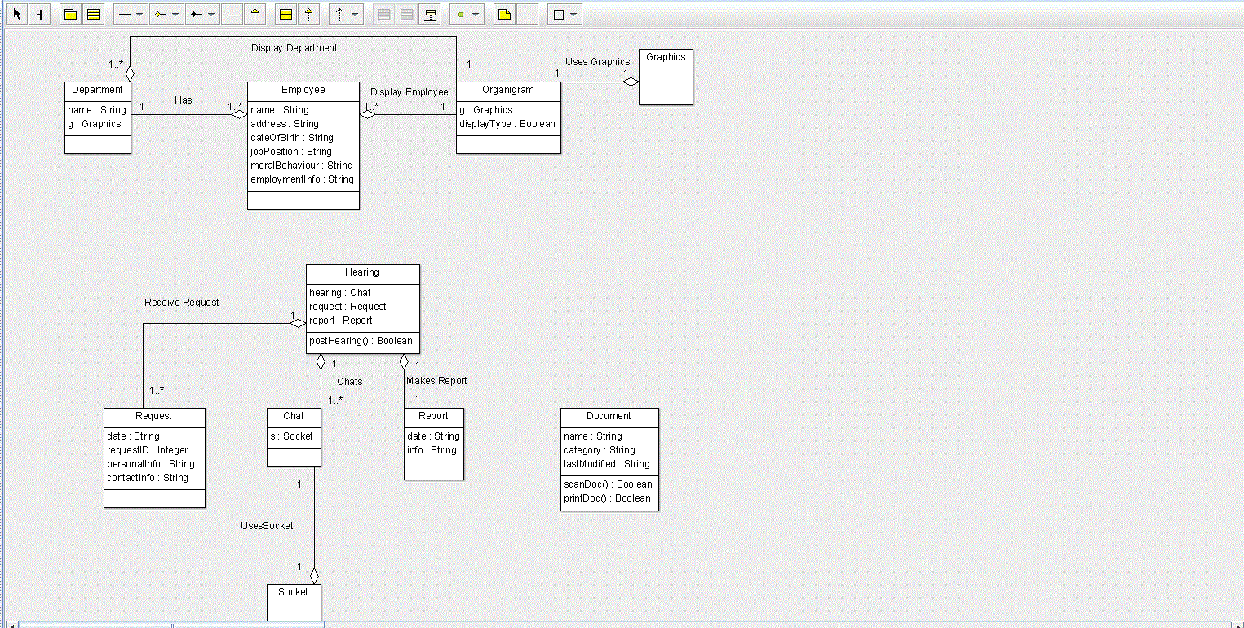

User Interface Design

Application Control

The first window that will appear in both client and server applications will be a login window. For the client application, after login, the chat window will be displayed. It will be activated accordingly to server schedule.
For the server application, after login, the main menu will be displayed. It will allow views of CHS, documents management and communication interface.
Screenshots and menu details will be available later.

